**~ Change table ~**

|  |  |  |  |  |  |
| --- | --- | --- | --- | --- | --- |
| Sr. no. | Change in colour | Description | Suggestion | Suggested to | Remarks |
| 1. |  |  |  |  |  |
|  |  |  |  |  |  |
|  |  |  |  |  |  |

B.K. Jewellers

**High Level Design (HLD)**

**Document for**

**“Stock management” part.**

Document NO: 001

Date: 09-02-2020

Prepared by:

Group 2

* **Table of Contents** -

|  |  |
| --- | --- |
| 1. | Introduction |
|  | * 1. Objective |
|  | 1.2 Scope |
|  | 1.3 Overview |
|  |  |
| 2. | General description |
|  | 2.1 Product perspective |
|  | 2.2 Tools used |
|  |  |
| 3. | General constrains |
|  |  |
| 4. | Assumptions |
|  | 4.1 Peripheral assumption |
|  | 4.2 Result assumption |
|  | 4.3 Knowledge assumption |
|  |  |
| 5. | Design details |
|  | 5.1 Application architecture |
|  | 5.2 Screen presentation |
|  | 5.3 Standards |
|  | 5.4 User interface |
|  | 5.5 Security |
|  | 5.6 Resource utilization |
|  | 5.7 Help |

1. **Introduction**
   1. Objective:

The purpose of this High Level Design (HLD) document is to add required details to the current project to make a suitable model for coding. This document can also be used as reference manual for how modules work at high level.

* 1. Scope:

The HLD document defines the full architecture of the “stock management” department in software.

* 1. Overview:

The HLD document will describe following:

* All the design aspects and defined in detail.
* User interface.
* Software interface.
* Resource utilization.
* Design features & architecture of project.

1. **General description**
   1. Product perspective:

The working of “sock management” department is build with several components some of them are programmed and others are implemented from open-source programs.

This section will allow only one user to work with software on one machine.

There is only one user “stock manager” which can view

* Item details,
* Daily stock,
* Transfer,
* Lost or query report.
  1. Tools used:
* Unified modelling language (UML) design programs to generate all diagram.
* Backend data-base is NoSQL type based.

1. **General constrains**

The “stock management” department must be user friendly and 90% automatic.

Stock manager should not be required to know working of accounts and manufacturing departments but he/she should be aware of sales department of organization.

Entry is saved stock manager can edit them only after informing sales merchandiser.

1. **Assumptions**
   1. Peripheral assumption:

The “account” department can work on only Microsoft Windows (7/8.1/10/above) . The required specifications are at least 4 GB of RAM and 100 GB of free storage space.

* 1. Result assumption:

The goal is to make the working within organization will follow the strict rules and procedures with less efforts and make the process simpler as much as possible.

* 1. Knowledge assumption:

The final assumption is that the person is operating the software is aware of basic usage of computers and at least 80% awareness of rules and procedures of the organization as well as 95% of knowledge in their working expertises.

1. **Design details** 
   1. Application architecture:

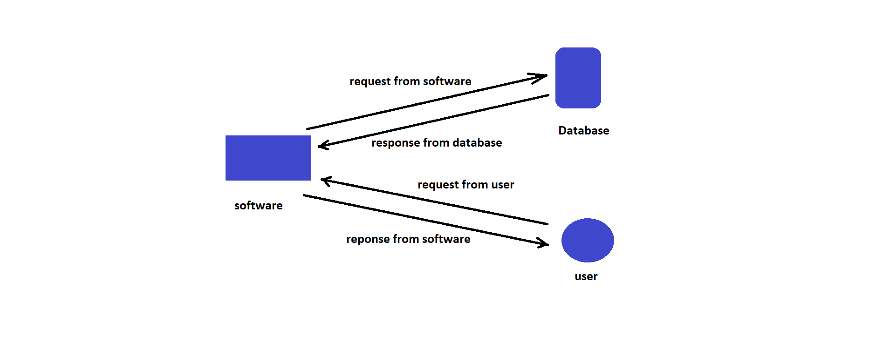

* 1. Screen presentation:

On “stock manager” side information will include

* Item details,
* Daily stock,
* Transfer,
* Lost or query report,
* Help.
  1. Standards:
* Inputs:- through barcode scanner and text fields.
* Security:- username and password are required.
* Quality:- by keeping simple and direct interface quality should be kept at a maximum.
* Accuracy:- the accuracy standard should always keep at very high when performing any operation.
  1. User interface:

The user interface is very simple plain layout with little to no graphics. It will display information very clearly for the users.

* 1. Security:

A username and password will be mandatory to log into the system as well as the software.

The generated voucher numbers shouldn’t be shown in any voucher afterwards.

* 1. Resource utilization:

When any task is performed, it will likely to use recommended processing power until that task get finished.

* 1. Help:

Help will come in the form of all documentation created prior to coding, which explain the intended user. Detailed instructions will be written in it.